SPECIAL EDUCATIONAL NEEDS AND DISABILITies (SEND) policy

Contact: Madeleine Bendell/Danielle Stone (SENCOs)

(also referred to as ECM – Every Child Matters)

Policy written: September 2020

Updated: May 2021

This policy will be reviewed and updated annually.



**NWLJDS SEND Policy Contents**

1. Introduction 3
2. Legislation and Guidance 3
3. Vision & Aims 4
   1. Our Vision

3.2 Our Aims

1. Roles and Responsibilities 6
   1. The SENCo
   2. The SEN Governor
   3. The Headteacher
   4. Class Teachers
   5. Learning Support Assistant (LSA) Responsibilities
   6. Parents
2. Identification of SEND and Graduated Response 10
   1. SEN Funding
   2. Graduated response to SEN
   3. EHCPs
   4. Pupils on the SEN Register
   5. Access Arrangements
3. Admissions and Transitions 15

6.1 Admissions

6.2 Transitions

1. Staff Training and Development 16
2. Facilities 17
3. School Information Report
4. Links to Other Policies 17
5. Complaints 18
6. Appendices

# 

# 1. INTRODUCTION

This policy is created in line with the requirements set out in Part 3 of the Pupils and Families Bill (2014) and associated regulations. The policy is fully compliant with the Special Educational Needs (SEN) Code of Practice: for 0 to 25 years (revised Code January 2015).

# 2. LEGISLATION AND GUIDANCE

North West London Jewish Day School (NWLJDS) identifies pupils as having Special Educational Needs (SEN) if they meet the definition as set out in the 2014 SEN Code of Practice (CoP 2014). Please note that SEN and SEND (Special Educational Needs and Disabilities) are used interchangeably throughout this policy and throughout SEN guidance. The CoP 2014 defines SEN as:

1.A child or young person has SEN if they have a learning difficulty or disability which calls for special educational provision to be made for him or her.

2. A child of compulsory school age or a young person has a learning difficulty or disability if he or she:

* has a **significantly greater difficulty** in learning than the majority of others of the same age, or
* has a **disability which prevents or hinders** him or her from making use of educational facilities of a kind generally provided for others of the same age in mainstream schools.

3. Many children who have SEN may have a disability under the Equality Act 2010 – ‘…a physical or mental impairment which has a long term and substantial adverse effect on their ability to carry out normal day-to-day activities’

NWLJDS provides Special Educational provision for pupils who require:

* ‘*special educational provision that is provision different from or additional to that normally available to pupils of the same age.*’

NWLJDS provides for pupils whose special educational needs broadly fall into the 4 areas of:

1. Communication and interaction
2. Cognition and learning
3. Social, emotional and mental health difficulties
4. Sensory and/or physical needs.

VISION & AIMS

## 3.1 Our Vision

At NWLJDS we believe that all of our pupils, regardless of gender, ethnicity, ability, or disability are entitled to a high-quality education that will maximise their life chances. All pupils are entitled to a school experience that enables them to:

* Achieve their best academically, socially and emotionally
* Learn about and strive for good mental health and wellbeing (refer to Mental Health and Wellbeing Policy)
* Become confident individuals living fulfilling lives
* Be active members of the wider community, embracing the values of Judaism
* Make a successful transition into secondary school, further and higher education or training and adulthood.

## 3.2 Our Aims:

1. We value the views of a pupil and will use different methods to ensure their views on their education are taken into account
2. Identify individual learning and emotional needs as early as possible as we believe early intervention is key.
3. Our pupils with SEN will be offered full access to a broad and balanced curriculum, differentiated to their needs.
4. Provide all children with equal opportunities to the wider community.
5. Work in partnership with parents and outside agencies to support the education and the social and emotional well-being of all children.
6. To provide support and advice to staff on the implementation of the SEN policy, with high-quality, relevant training where needed.
7. Encourage every teacher to have responsibility for meeting the learning and emotional needs of **all** pupils in their care. To work together to ensure quality first teaching, so learning is appropriately differentiated. This includes children who are working at greater depth.

We also work collaboratively with parents and outside agencies to ensure that all vulnerable groups make good progress across the school.

This includes:

• Looked after children.

• Pupil premium children

• Children with English as an Additional Language

• Children known to social services or on the Child Protection Register

# 

# 4. ROLES AND RESPONSIBILITES

Everyone has a collective responsibility in ensuring children with SEN thrive at NWLJDS. In particular, this policy outlines the roles of the SENCO, Headteacher, SEN Governor, Teachers, LSAs (general and one-to-one) and Parents.

## 4.1 The SENCO

The SENCOs are **Madeleine Bendell** and **Danielle Stone.**

The SENCO’s key responsibilities are:

* The SENCO of the school must hold a Postgraduate Certificate in SEN Co-ordination (NaSENCO qualification).
* Work with the headteacher and SEN governor to determine the strategic development of the SEN policy and provision in the school.
* Have day-to-day responsibility for the operation of this Inclusion Policy and the co-ordination of specific provision made to support individual pupils with SEN, including those who have Education, Health and Care plans (EHCPs).
* Provide professional guidance to colleagues and work with staff, parents, and other agencies to ensure that pupils with SEN receive appropriate support and high-quality teaching.
* Facilitate training opportunities for all staff.
* Ensure there is a graduated approach to providing SEN support.
* To provide the parents with the opportunity to discuss their child’s needs and progress made.
* To manage the school’s SEND budget and resources.
* To work effectively with external agencies, the local authority and support services.
* Ensure effective and smooth transition for incoming pupils and leavers.
* Ensure the school keeps the records of all pupils with SEN up to date
* To remain up to date with all legislation relating to SEN and to have continuous professional development through courses and forums.
* Work with the headteacher and governing board to ensure that the school meets its responsibilities under the Equality Act 2010 with regard to reasonable adjustments and access arrangements

## 4.2 The SEN Governor

The SEN Governor is **Martin Kerem.**

The SEN Governor’s key responsibilities are:

* to raise awareness of SEN issues at governing board meetings
* to monitor the quality and effectiveness of SEN and disability provision within the school and update the governing board on this
* to work with the headteacher and SENCO to determine the strategic development of the SEN policy and provision in the school

## 4.3 The Headteacher

The headteacher is **Judith Caplan.**

The headteacher’s key responsibilities are:

* to work with the SENCO and SEN governor to determine the strategic development of the SEN policy and provision in the school
* Have overall responsibility for the provision and progress of learners with SEN and/or a disability
* To attend annual reviews for children with EHC Plans and termly Pupil Progress meetings
* To bring to the attention of the Governors any prospective parent who has named NWLJDS on their child’s EHCP. *(The child’s paperwork needs to be read fully by the headteacher and a consultation between the headteacher, ECM team and Governors must take place before replying to the Local Authority in which the child’s resides within the deadline)*

## 4.4 Class teachers

The class teacher’s key responsibilities are:

* To ensure quality first teaching for all
* To monitor the progress and development of every pupil in their class
* Raising concerns about an individual pupil’s needs
* To effectively deploy all additional adults in the classroom and to assess the impact of support and interventions.
* To discuss children’s needs with the entire teaching team (including Kodesh staff, learning support assistants (LSA), one-to-one LSA’s and intervention teachers) and liaise with involved agencies.
* Working with the SENCOs to review each pupil’s progress and development and decide on any changes to provision
* To provide the parents with the opportunity to discuss their child’s needs and progress with regular opportunities to feedback
* Developing Individual Education Plan (IEP) targets for children with an EHCP, to be completed termly
* The class teacher should produce a report for any child with an EHCP for their annual review
* A commitment to professional development in areas of SEN training throughout the academic year.

## 4.5 Learning Support Assistant (LSA) Responsibilities

This applies to General LSAs and one-to-one LSAs

The LSA’s key responsibilities are:

* To liaise with the children’s class teacher and to create/review targets in the Individual Education Plans (IEP)
* To follow treatment plans as suggested by outside agencies
* To keep records of assessment and evaluation of impact of teaching interventions
* To attend annual reviews and produce a report for meetings with the class teacher (for pupils with an EHCP only)
* To work with children to provide individual and group support

## 4.6 Parents

All parents and carers of pupils with special educational needs at NWLJDS are considered to be our partners. The school will support parents to be able and feel empowered to:

* To play an active and valued role in their pupil’s education
* Have knowledge of their child’s entitlement within the SEN framework
* Share their views on the child’s educational experience
* Stay updated and informed about their child’s provision and progress

# 5. IDENTIFICATION OF SEND AND GRADUATED RESPONSE

## 5.1 Methods of Identification

Identification includes the use of high-quality formative assessment, as well as effective tools and early assessment materials.

Teachers regularly assess the progress made by all pupils. This helps to identify any pupil who is not making the expected level of progress. Teacher observation also helps to identify whether a pupil has a need socially or emotionally.

Identified needs are shared with the teaching team and SENCOs and meetings arranged with parents. Equally, if concerns are raised by parents, all parties meet to discuss the course of action.

For all year groups, there are termly Pupil Progress meetings that are led by the Assessment Co-ordinator. These meetings always involve input from the headteacher, class teachers and SENCO. This provides opportunities to monitor children’s academic progress, attainment and wellbeing. Any further action necessary is discussed and planned at these meetings.

At NWLJDS, we work together with outside agencies (see some examples below). If further referral for assessment to these agencies are needed, then parental consent is always sought.

* Educational Psychologist
* CAMHS – Children and adolescence mental health services
* WEST – Wellbeing and Emotional Support Team (Brent)
* Speech and Language Therapist
* Occupational Therapist
* School-based Play Therapist
* School-based Psychotherapist
* Brent Inclusion Services
* Advisory Teacher for Autism Spectrum Disorder
* Advisory Teacher for Hearing Impairment
* Advisory Teacher for Vision Impairment
* Teacher of the Deaf

## 5.2 Graduated Response

### 5.2.1 SEN Funding

The school’s SEN provision is funded largely from the school’s main budget and is allocated on the basis of individual need. Support is allocated according to needs, priorities and availability of resources.

In exceptional cases, if the school cannot adequately meet the child’s needs, it can apply to the Local Authority for top up funding.

Pupils who have an EHCP will have provision in place (funded by school and local authority).

### 5.2.2 Graduated Response to SEN

For children with SEN needs (but no EHCP) the school ensure effective provision is in place and monitored according to what is known as the “graduated approach”. This ensures decisions and actions are revisited, refined and revised with growing understanding of the child’s needs. It also ensures continuous evaluation of support to secure good progress and good outcomes.

The diagram below depicts the graduated approach:

1. Assess needs
2. Plan
3. Do
4. Review

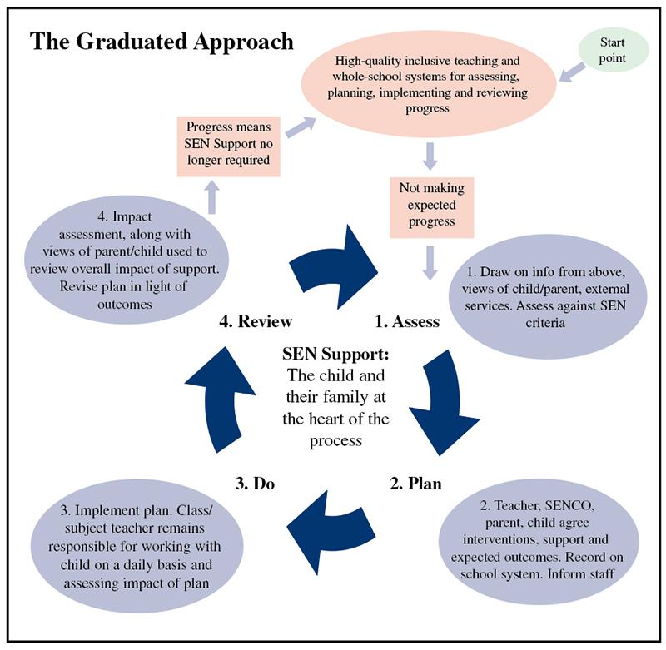

Image by Natalie Packer, [www.nataliepacker.co.uk/](http://www.nataliepacker.co.uk/)

### 5.2.3 EHCPs

If a child makes little or no progress, despite provision and support, after two cycles of “assess, do and review” it is possible to make a request to the local authority for assessment for EHC plan. This is a lengthy process that requires evidence of support and impact.

The local authority meet on a multi-disciplinary panel and decide whether an assessment is necessary. If an assessment is granted, a child’s needs are assessed further and the panel meet again and decide if an EHC plan is issued.

If a pupil has an EHC Plan, the SENCO will lead the implementation of all provision and ensure the teaching team work together with parents, staff and pupil.

Each term, Individual Education Plans (IEPs) are written for the pupils who have an EHC Plan. These targets reflect the needs of the child and the advice from the professionals supporting the child. These are SMART targets (Specific, Measurable, Attainable, Realistic and Time-Bound) to ensure attainable progress. IEPs are shared with staff and parents on a termly basis.

There are formal annual meetings to review the provision in place. Views are taken from pupils, parents, school and other professional involved as to whether provision needs adapting. (In nursery, children are entitled to two biannual reviews). These are a statutory requirement and includes the involvement of the LA.

This image outlines the timescale of the EHC plan process.

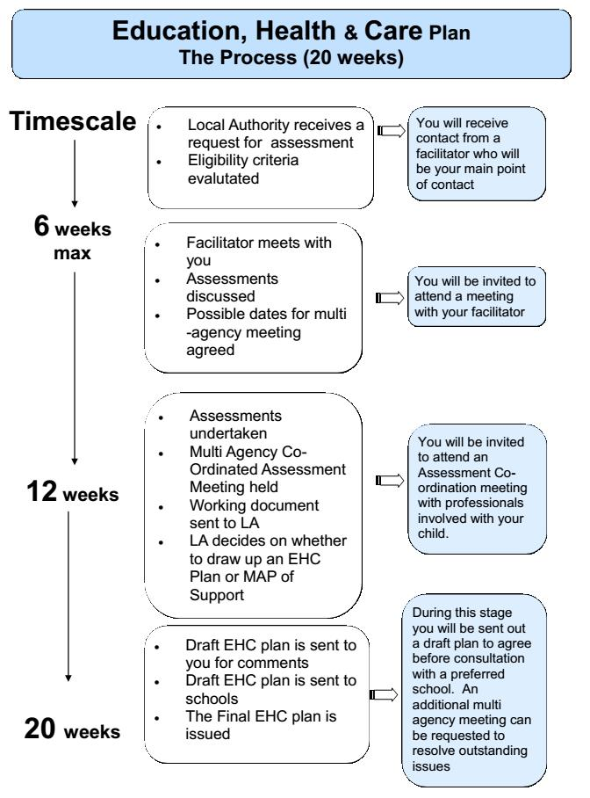

### 5.2.4 Pupils on the SEN Register

For children who are receiving provision or intervention above and beyond regular classroom practice (e.g. social skills group, counselling) they are placed on what is known as the SEN register. This allows careful monitoring of children’s progress. It is a working document that is reviewed termly and parents are notified in writing if their child is named on the register, and when they no longer require extra provision they are taken off.

### 5.2.5 Access Arrangements

The school will ensure that it meets its responsibilities under the Equality Act 2010 with regard to reasonable adjustments and access arrangements. Children sit Standardised Assessment Tests (SATs) in Years 2 and 6.

For Year 6, the school must follow the JCQ guidelines for access arrangements. For each pupil an application for additional time needs to be completed. The JCQ determines whether the pupil is granted this extra time for SATS. Children with an EHCP are automatically granted 25% additional time for assessments.

Other arrangements, for example, modified or enlarged papers or use of scribe must reflect normal classroom practice. The ECM team in consultation with the assessment coordinator are responsible for applying for these access arrangements should they be appropriate. These arrangements also take place when summative and formative assessments take places across all year groups.

# 

# 6. ADMISSIONS AND TRANSITIONS

## 6.1 Admissions

Admission for a child with SEN (who does not have an EHCP) is the same as for all children and is in accordance with the Local Authority’s Admission Criteria and no child will be discriminated against.

For children applying for a place at NWLJDS with an EHCP, the local authority begins a consultation process to determine whether NWLJDS can meet the child’s needs in accordance to their EHCP.

The school has 15 days to review all necessary reports and paperwork and respond to the local authority.

Please see the Admissions Policy for further information.

## 6.2 Transitions

All transitions are carefully planned for, including internal transitions between year groups, key stages and new joiners. We have whole school procedures in place for these transitions and additional procedures are put in place for any pupil who requires additional support.

For children identified with SEN, information is gathered from previous settings and parents to ensure that all relevant documentation is shared. This allows us to appropriately plan and provide support.

We also ensure smooth transition for children leaving NWLJDS to new schools.

# 

# 7. STAFF TRAINING AND DEVELOPMENT

At NWLJDS all of our staff receive continued professional development on meeting the needs of all of our learners. This includes: SEN, mental health and wellbeing, English as an Additional Language (EAL) and quality first training.

An audit of staff training needs is carried out at the beginning of the academic year and explored in relation to the current needs of our pupils. Half termly training is given specifically to the LSA team around matters such as delivering interventions and monitoring progress. There is also an opportunity for staff to feedback and disseminate information on any courses they have recently attended during team meetings to enable good practice to be shared.

In addition to this all staff are able and encouraged to access external courses and online courses that will benefit them in their role of supporting all of our learners.

# 

# 8. FACILITIES

NWLJDS is committed to equal opportunities. The school seeks to comply with the 2010 Discrimination and Disability Act and take our legal duty seriously. Where possible we also make reasonable adjustments to the school building (e.g. acoustic panelling, floor markings).

# 9. SCHOOL INFORMATION REPORT

All information about our SEN provision is included in our SEND School Information Report which is published on our website and updated annually.

Please also see the Brent Local Offer for more information about local services. <https://www.brent.gov.uk/services-for-residents/children-and-family-support/the-brent-local-offer/>

For pupils not living in Brent, please refer to own local authority for more information.

# 10. LINKS TO OTHER POLICIES

This policy is closely linked with the SEND information report and both documents can be found on our school’s website and should be the first point of information for parents if they have concerns about their child’s needs. On the website, there is also a link to the Brent LA Local Offer for SEND.

All of our policies are developed with a high priority on children’s safety and in light of our safeguarding policy. Other relevant documentation that links with this policy are:

* Behaviour Policy
* Anti-Bullying Policy
* Child Protection Policy
* Supporting pupils with medical conditions
* Mental Health and Wellbeing Policy
* Accessibility Plan
* Safeguarding Policy
* E-Safety Policy

# 11. COMPLAINTS

Complaints about SEN provision in NWLJDS should be made to the class teacher in the first instance. The SENCO should then be contacted. If the issue has not been resolved, we advise parents to refer to our school complaint’s policy.

The parents of pupils with disabilities have the right to make disability discrimination claims to the SEND tribunal if they believe that NWLJDS has discriminated against their children. They can make a claim about alleged discrimination regarding:

* Exclusion
* Provision of education and associated services
* Making reasoning adjustments.

Please see the school’s complaints policy for further information.

# 12. APPENDICES

Here is a glossary of the most used SEN terms, which are often abbreviated.

|  |  |
| --- | --- |
| ADD | Attention Deficit Disorder |
| ADHD | Attention Deficit and Hyperactivity Disorder |
| ASD | Autistic Spectrum Disorder |
| BOAT | Brent Outreach and Autism Team |
| BST | Behaviour Support Team |
| CAF | Common Assessment Framework |
| CAMHS | Child and Adolescent Mental Health Service |
| COP | Code of Practice |
| CP | Child protection |
| DCD | Developmental Co-ordination Disorder |
| EAL | English as an Additional Language |
| EHCP | Education, Health and Care Plan |
| EP | Educational Psychologist |
| EPS | Educational Psychology Service |
| EWO | Educational Welfare Officer |
| FSM | Free School Meals |
| HI | Hearing Impairment |
| IEP | Individual Education Plan |
| KS | Key Stage |
| LA | Local Authority |
| LAC | Looked After Child |
| MLD | Moderate Learning Difficulty |
| NC | National Curriculum |
| OT | Occupational Therapist |
| PP | Pupil Premium |
| PSP | Pastoral Support Plan |
| SALT | Speech and Language Therapist |
| SEMH | Social, Emotional and Mental Health |
| SEN | Special Educational Needs |
| SEND | Special Educational Needs and Disability |
| SLCN | Speech Language Communication Needs |
| SPLD | Specific Learning Difficulty |
| TAC | Team around the Child |
| TAF | Team around the Family |
| ToD | Teacher of the Deaf |
| VI | Visual Impairment |