

Statement: | Accessibility plan
This statement was approved: | September 2019
This statement will be reviewed: | September 2022  (Reviewed annually and revised every 3 years)
Governor committee responsibility: | Full Governing Body

At North West London Jewish Day School (NWLJDS) our values reflect our commitment to a school where there are high expectations of everyone. Children are provided with high quality learning opportunities so that each child attains and achieves all that they are able to. Everyone in our school is important and included. We promote an ethos of care and trust where every member of our school community feels that they truly belong and are valued. We work hard to ensure we recognise everyone’s uniqueness and success. We recognise learning in all its forms and are committed to nurturing lifelong learners. We are a safe school, committed to improving children's confidence and self-esteem. We know that safe and happy children achieve.

This Accessibility Plan is drawn up in compliance with current legislation and requirements as specified in Schedule 10, relating to Disability, of the Equality Act 2010. School Governors are accountable for ensuring the implementation, review and reporting of progress of the Accessibility Plan over a prescribed period.

The Equality Act 2010 replaced all existing equality legislation, including the Disability Discrimination Act. The effect of the law is the same as in the past, meaning that “schools cannot unlawfully discriminate against pupils because of sex, race, disability, religion or belief and sexual orientation”.

According to the Equality Act 2010 a person has a disability if:

- He or she has a physical or mental impairment, and

- The impairment has a substantial and long-term adverse effect on his or her ability to carry out normal day-to-day activities.

We understand that the Local Authority will monitor the school’s activity under the Equality Act 2010 (and in particular Schedule 10 regarding Accessibility) and will advise upon the compliance with that duty.

Objectives

NWLJDS is committed to providing an environment that enables full curriculum access that values and includes all pupils, staff, parents and visitors regardless of their education, physical, sensory, social, spiritual, emotional and cultural needs. We are committed to taking positive action in the spirit of the Equality Act 2010 with regard to disability and to developing a culture of inclusion, support and awareness within the school.

The school recognises and values parent’s knowledge of their child’s disability and its effect on their ability to carry out everyday activities and respects the parent’s and child’s right to confidentiality.

The NWLJDS Accessibility Plan shows how access is to be improved for disabled pupils, staff and visitors to the school within a given timeframe and anticipating the need to make reasonable adjustments to accommodate their needs where practicable.

The Accessibility Plan contains relevant and timely actions to:-

- Increase access to the curriculum for pupils with a physical disability and/or sensory impairments, expanding the curriculum as necessary to ensure that pupils with a disability are as equally prepared for life as the able-bodied pupils; (If a school fails to do this they are in breach of their duties under the Equalities Act 2010); this covers teaching and learning and the wider curriculum of the school such as participation in after-school clubs, leisure and cultural activities or schools visits – it also covers the provision of specialist or auxiliary aids and equipment, which may assist these pupils in accessing the curriculum within a reasonable timeframe;

- Improve and maintain access to the physical environment of the school, adding specialist facilities as necessary – this covers improvements to the physical environment of the school and physical aids to access education within a reasonable timeframe;

- Improve the delivery of written information to pupils, staff, parents and visitors with disabilities; examples might include hand-outs, timetables, textbooks and information about the school and school events; the information should be made available in various preferred formats within a reasonable timeframe.

The NWLJDS Accessibility Plan relates to the key aspects of physical environment, curriculum and written information.

Whole school training will recognise the need to continue raising awareness for staff and governors on equality issues with reference to the Equality Act 2010.

The Accessibility Plan for physical accessibility relates to the Access Audit of the School, which remains the responsibility of the governing body. It may not be feasible to undertake all of the works during the life of this accessibility plan and therefore some items will roll forward into subsequent plans. An accessibility audit will be completed by the school prior to the end of each period covering this plan in order to inform the development of a new Accessibility Plan for the ongoing period.

Equality Impact Assessments will be undertaken as and when school policies are reviewed. The terms of reference for all governors’ committees will include the need to consider Equality and Diversity issues as required by the Equality Act 2010
The Accessibility Plan will be published on the school website.

The Accessibility Plan will be monitored through NWLJDS with the Premises Governor, Arnie Kosiner, leading this area.

The Accessibility Plan may be monitored by Ofsted during inspection processes in relation to Schedule 10 of the Equality Act 2010.

Approved

Date

It is a requirement that the school’s accessibility plan is resourced, implemented, reviewed and revised as necessary and reported on annually. Attached is a set of action plans showing how the school will address the priorities identified in the plan.

The priorities for the Accessibility Plan for our school were identified by:

The Governing Body
- Head Teacher
- Senior Leaders
- SENCo
- School Business Manager
- Site Manager

A plan of the school buildings showing areas of accessibility is shown below

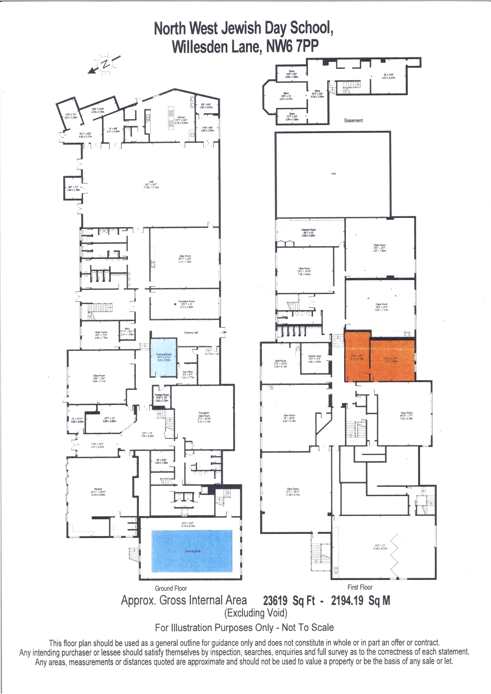

Physical Access

Previous progress before 2019:
- Accessible toilet plus changing table
- Yellow strips on stairs for visually impaired
- Acoustic paneling in Years 3 and 5

Access Report Ref. | Item | Activity | Timescale | Cost | Evaluation
1. | Making NWLJDS more accessible for hearing impaired pupils, staff, parents and other users. | Hearing Impairment Audit from Brent by Milly Mastroianni (Teacher of the Deaf). Action her recommendations.  Quotes collected from 3  companies to make our  school more HI friendly.  Sound proofing feet of chairs.  Set up training for specific cohorts on HI at the start of every year. Training to look at best practice. | By end of Term 2 2019-2020  By end of Term 3 2019-2020 for the classes the following year that have pupils with HI.  September 2019, September 2020 and September 2021. | To acoustically improve Y3 (both classrooms) approx costing:  £3500  Or alternatively quote can be split for main class and separate classroom.  (Please refer to quotes collected). | October 2021:  Acoustic paneling installed in all learning spaces, including School Hall. Project funded by charity, The JDA  Annual HI training for cohorts with HI pupils (usually at the beginning of a new academic year)
2. | Reviewing our personal, emergency and evacuation plan. | Trial emergency drills each half term and evaluate. Ensure all emergency exits are accessible at all times.  Health and Safety Walks

Curriculum Access

Access Report Ref. | Item | Activity | Timescale | Cost | Evaluation
1. | Provision Maps | SENCO to lead updating of provision maps in 4 areas based around code of practice. | Termly 2019-2022 | No cost – SENCO time | Termly updates of provision map including interventions delivered
2. | Resources | Ensure every class or key stage is equipped to meet high incidence low level needs (e.g. range of pencil grips, wobble cushions, fidget toys, slopes, coloured overlays, Ipads etc). | Beginning of 2020-2021 | Approx £60 per box  £480 for whole school | Organising room charges for private therapy (SLT; OT) to purchase resources for all classrooms (October 2021)
3. | Training & links | Provide appropriate and relevant ongoing training all staff on matters of inclusion – Hearing Impairment, Austism, Downs Syndrome, Speech Therapy – Communication Keys etc. | Ongoing throughout 2019 -2022 | As much as possible NHS and Brent training will be accessed so only £100 set aside for this | SEN insets each half term  Training in 2020 included dyslexia, Word Aware, Epilepsy, mental health  Planned training for 2021/22: ADHD  Epilepsy, Brent SLT courses,  Access to National College for independent CPD relating to SEN

Written Information Access

Access Report Ref. | Item | Activity | Timescale | Cost | Evaluation
1. | Clear, straight forward and simple communication with parents and community | Information presented in variety of easy to access ways e.g. displayed in window for parents dropping off, sent via email, text and on school website.  Language used is simple with any education terms/jargon avoided or clearly explained.  Parent guides produced & parents sessions run for key areas  Admin & teaching staff aware of individual who may need information explaining directly or personally.  Parents who are separated to ensure communication is given to both mum and dad.  Ensure all parents/carers have access to the information the school gives out. Ask them what is their chosen method of communication for them so their needs can be met.  Communication can be made available in different languages if appropriate. | September 2019 and ongoing
2. | Varied forms of communication across different platforms | Establish a Facebook profile that is regularly updated for easy access.  Effective use of Parent Mail with clear communication  Updated website for parents to access

